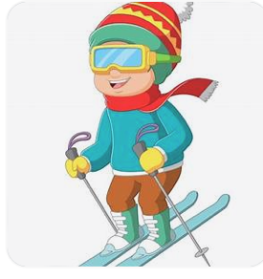

Winter Sports Winter Planning Party
Sunday, July 12

Gather 11:00 AM Brunch 12:00
Nancy and Craig Navis
3655 Greensboro Drive, Eagan

Bring your ideas for a one day or multi day downhill,
cross-country, or snowshoeing event. You only need to pick
a date, time and place, and if desired,
a place to socialize for lunch or dinner.

Baked Egg Dish and Beverages provided. Please bring a breakfast side dish and $2 donation.

Directions:
494 to Pilot Knob Road, head south to Wescott Road. Turn Left and continue 1.5 miles to Greensboro Drive. (Take the second Greensboro Drive, there are two)

RSVP by July 10:
Karen Holmquist 952-270-4739
Karen.holmquist49@gmail.com
